**HOTELS**

|  |  |
| --- | --- |
| |  | | --- | | **MONT CERVIN PALACE**  C:\Users\Ray\Desktop\Mont Cervin Palace.jpg**C:\Users\Ray\Desktop\Mont Cervin Palace - Terrasse.jpg**  Situated at the heart of Zermatt, the Mont Cervin Palace stands out with its attractive south-façade and roof with numerous turrets. And the hotel’s red horse-drawn carriage is an ever popular photo motive. Excellent cuisine at the restaurant-dining room, Grill Le Cervin, large indoor swimming pool with out door pool, sauna, large patio. Banqueting and conference facilities for up to 300 persons. | |
| |  | | --- | | Transfer by private taxi from Geneva, Zurich or Sion Airport upon request, transfer train station - hotel - station incl. MCP Beauty & Spa, pets allowed execept in the dining roomIn winter: ski service, nurse, kindergarten at the Hotel Schweizerhof, baby-sitting upon request. | |

|  |
| --- |
| Bahnhofstrasse 31 3920 Zermatt |
| |  | | --- | | Tel.: +41 27 966 88 88 Fax: +41 27 966 88 99 | |

**RIFFELALP RESORT 2222 m.ü.M.**

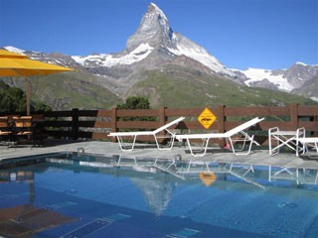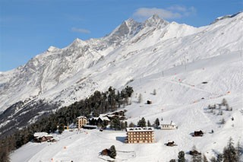

|  |  |
| --- | --- |
| |  | | --- | | "Riffelalp Resort 2222m" is situated at the heart of Gornergrat skiing/hiking area. The 65 rooms and 5 suites are fully equipped with modern 5\* amenities. Restaurants: Alexandre - high cuisine; Walliser Keller - local specialities; Ristorante al Bosco - Italianita in Montagna; Pianobar. Pool and wellness center with Europes highest out door pool. Conference and banquet possibility. | |
| |  | | --- | | Our rates include: Arrival and departure train with the GGB, daily night train to and from the village, pool and wellness. We also offer: wine bar, smokers lounge, bowling, massage, kindergarten and several sport activities. | |

|  |
| --- |
| Riffelalp 3920 Zermatt |
| |  | | --- | | Tel.: +41 27 966 05 55 Fax: +41 27 966 05 50 | |

**GRAND HOTEL ZERMATTERHOF**

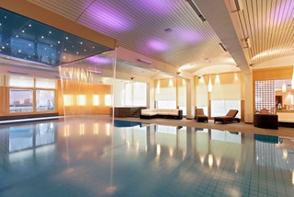 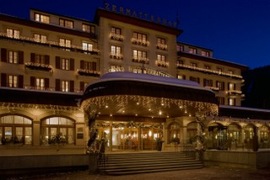

|  |  |
| --- | --- |
| |  | | --- | | Tradition and luxury for demanding guests in the center of Zermatt. 81 rooms and suites. Part of the rooms with balconies, fire-place, Jacuzzi, two restaurants, two bars, reputed cuisine, new spa "vita borni" including alarge indoor-pool, sauna, fitness, steambath, jacuzzi, alpine and ice grotto. 5 Massage and Beauty treament rooms with products from St. Barth and Cellcosmet. Wireless lan in all hotel areas available. Banquett and conference facilities for up to 250 persons. | |
| |  | | --- | | In our restaurants we appreciate a classic or elegant dress code corresponding to the style of the hotel. Children in parents room free up to 8 years, 50 % reduction from 9 to 12 years. Babysitting on request. Dogs allowed on rooms at Fr. 35.- per day without food. | |

|  |
| --- |
| Bahnhofstrasse 55 3920 Zermatt |
| |  | | --- | | Tel.: +41 27 966 66 00 Fax: +41 27 966 66 99 | |

**RESTAURANTS**

**Gourmetstübli**

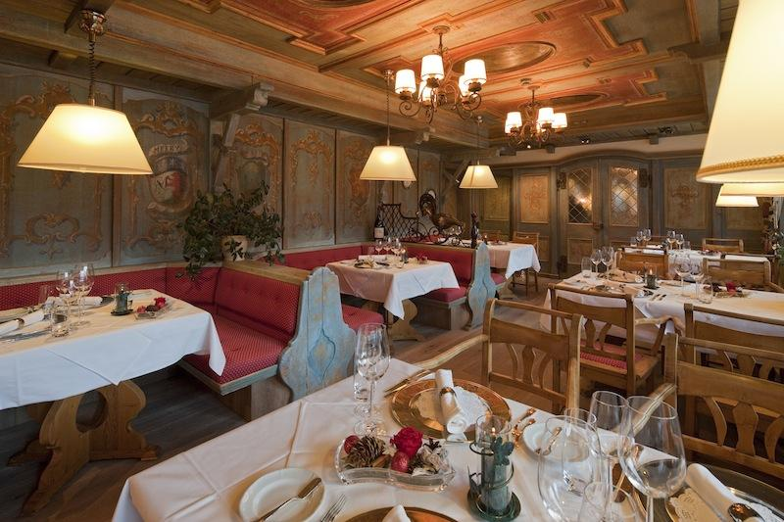

You can enjoy both culinary highlights and fascinating views of Zermatt and the Matterhorn. The owner will be happy to personally recommend top wines from all around the world to accompany the fine creations from the kitchen.

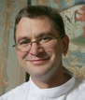 **Reinhold Wrobel, Executive Chef**

"Culinary highlights with a stunning view."  
  
Speciality: Variants on duck’s liver and bison filet "House style".

Reservations: +41 27 966 34 34

# Ristorante Capri

# C:\Users\Ray\Desktop\resized_800x533_2403___434955.jpg

# The restaurant on the 4th floor of “Le Petit Cervin” ensures culinary highlights with its excellent Mediterranean cuisine, and is hailed by Gault Millau as the best Italian restaurant in Switzerland. Fantastic views included! (Only open in the winter.)

# C:\Users\Ray\Desktop\resized_91x138_91x138_pierludovico_de_vivo.jpg **Pierludovico de Vivo, Executive Chef** "Mediterranean cuisine directly imported for you. A breath of sea air at the foot of the Matterhorn." Speciality: Traditional, Mediterranean cuisine rediscovered.

# Reservations: +41 27 966 88 88

# Alpenhof Le Gourmet

# C:\Users\Ray\Desktop\resized_800x533_800x533_alpenhof.jpg

# The Hotel Alpenhof offers a wide range of cuisine at its very best. In the new Zino Platinum Cigar Lounge, you can also crown the delicious Alpine-Mediterranean cuisine by enjoying a fine cigar by the huge open fireplace.

# C:\Users\Ray\Desktop\resized_92x61_92x61_heinz_rufibach.jpg **Heinz Rufibach, Executive Chef**

# "We celebrate an Alpine-Mediterranean cuisine with regional and southern European dishes." Speciality: Loup de mer (absinthe – Taggiasca olives – fennel) / Lamb filet (Grissini – basil – rye flour gnocchi – peperonata).

# Reservations: +41 27 966 55 55

**Places to have fun**

**Broken Bar/Disco**

**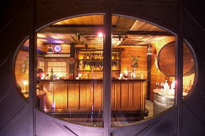**

In the oldest cellar of the village you will find Zermatt's cult disco. You can dance on the legendary wine barrel.

Ph.:+41 27 967 19 31

**GramPis Disco - THE CAVE**

**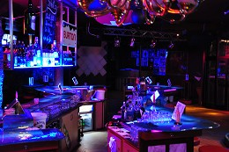**

Already our party club "The Cave" is nearly legendary. You will experience many special events, live acts and unforgettable moments until early in the morning.   
  
Opening times: Wednesday until Sunday (winterseason)

Ph.:+41 27 967 77 88

**Hennu Stall Après-Skihütte**

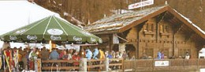

The après-ski lodge (between Furi and Zermatt) is the best place for a good mood after a day of skiing with DJ music and live band. Private parties upon request.  
  
Price category: Standard  
Terrace / Live music.

FOR MORE INFORMATION ABOUT ZERMATT: http://www.zermatt.ch/en/

PHOTO GALLERY!

**http://www.zermatt.ch/en/page.cfm/interactive/photo\_gallery**